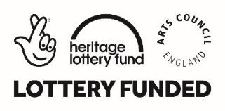

Project Manager for Pioneering Places East Kent: Folkestone

APPLICATION PACK

Thank you for your interest in the above freelance role for the Pioneering Places East Kent: Folkestone programme.

Details of the background and context for this role can be found in this pack.

Previous applicants need not apply

How to apply

Please complete the following:

1. An Application form
- An up to date CV which explains any gaps in employment

Once you have completed your application documents, please return them before the closing date to:

Penni Pierce
Executive and Project Assistant
Creative Foundation
Quarterhouse
Mill Bay
Folkestone
Kent CT20 1BN

Or alternatively, please email your completed application to:
pennipierce@creativefoundation.org.uk

If you have any questions relating to this role, please contact Lewis Biggs by email: lewisbiggs@creativefoundation.org.uk

Deadline
Closing date for applications: Friday 16th November 17.00
Interview date and location: 29th November, Folkestone

ABOUT THE CREATIVE FOUNDATION

Our Vision

The Creative Foundation is a unique arts organisation with a range of activities meaning it makes a positive difference to the town, the region, its inhabitants and its visitors. This gives the charity a significant advantage in making it a great place to work.

Our Mission

The Creative Foundation is an independent arts charity dedicated to enabling the regeneration of Folkestone through creative activity. Working with the people of Folkestone, our partners and other stakeholders we will transform the town making a better place to live, work, visit and study.

Our goals and objectives

Goal 1: Creatively engage the people of Folkestone
Objective 1: Bring quality art to the town for everyone in Folkestone
Objective 2: Bring quality creatives to Folkestone and the Creative Quarter
Objective 3: Provide opportunities for people to develop creatively
Objective 4: Encourage creative engagement with partners and agencies

Goal 2: Creatively transform the look of Folkestone
Objective 1: Bring artwork to the town
Objective 2: Creatively maintain the Creative Foundation portfolio
Objective 3: Ensure the Creative Quarter public realm looks and feels
attractive
Objective 4: Encourage creative engagement by relevant bodies and
individuals with property and the public realm

Goal 3: Creatively change the economy of Folkestone
Objective 1: Attract and retain new creative businesses
Objective 2: Deliver the creative visitor economy
Objective 3: Attract creatively engaged people to live in Folkestone
Objective 4: Encourage creative investment in Folkestone by others

Goal 4: Change the reputation of Folkestone as a creative town
Objective 1: Promote the Creative Foundation model for immersive
creatively-led regeneration
Objective 2: Effective promotion of Creative Foundation activities
Objective 3: Create a virtual Creative Foundation through digital
technology
Objective 4: Encourage others to promote the reputation of Folkestone

Goal 5: Create a sustainable Creative Foundation
Objective 1: Have a clear understanding of CF’s vision, mission, values
and business plan
Objective 2: Align the financial model with the organisation's vision
Objective 3: Invest in resources, including staff, to deliver the vision
Objective 4: Build appropriate partnerships to deliver the vision

http://www.creativefoundation.org.uk/
Other Creative Foundation projects:
Creative Quarter
Quarterhouse
Folkestone Book Festival
Folkestone Artworks
Folkestone Triennial

Freelance Opportunity

Role: Project Manager, Pioneering Places East Kent: Folkestone. Freelance consultants and consultancy firms are welcome to apply

Fee: Please specify your proposed fee in the application, which will be in the region of £25k for the period January 2019 to December 2020. The schedule of payments against tasks will be agreed after appointment.

Reports to: Lewis Biggs, Creative Foundation Visual Arts Curator

Location: To work remotely

Hours: As many as are required to fulfil the role to end December 2020 (there will be weeks in which you will be working 5 days and others in which you will not work at all).

Context
Pioneering Places East Kent is part of the national Great Place Scheme, an ambitious project that will make East Kent an even better place to live, work and visit by exploring heritage, developing civic pride and connecting artists and communities. Four exemplar projects in Canterbury, Dover, Folkestone and Ramsgate are being led by local cultural organisations to influence policy makers, and encourage any and all of the residents themselves to bring in change and become great place-makers.

Supported by the National Lottery through Arts Council England and the Heritage Lottery Fund, with Historic England and Artswork, the South East Bridge. Please see Appendix 1.

Key Objectives

We are now in the Delivery Phase of the programme and are looking to appoint a skilled and experienced freelance Project Manager to work on the Creative Foundation / Folkestone based part of the programme until December 2020. The Project Manager will be responsible to Creative Foundation through the Visual Arts Curator for day to day management of the two constituent programmes of the project (the history programme is now complete):
- masterplanning and imagining the future of the neighbourhood and its presentation;
- eliciting proposals from artists, and implementing the commission of those that are successful, in the context of the 2020 Folkestone Triennial.

The Project Manager will work directly and responsibly with all stakeholders (local people, Residents Associations, local arts organisations and NGOs, local and district authorities).

Key Responsibilities:

- To manage the schedule, integration and successful delivery of the two programmes
- To support the Curator in managing the project budget, including agreed cashflow, through implementing financial systems.
- To provide the Project Director with progress reports and financial information for the quarterly payment applications to the Heritage Lottery Fund.
- To provide the Project Director with information necessary for the quarterly Monitoring and Steering Group meetings
- To attend Pioneering Places Delivery Group meetings
- To work within the procurement requirements of the funders of the project.
- To identify key risks to enable development and improvement to the delivery of the programme
- Assist with the appointment and management of associated freelance Project Managers.
- Support the Creative Foundation, and Curator, in managing relations with the local Council as regarding artworks, permissions etc.
- Contribute to research of appropriate ‘participating experts’ (architects, artists, urban planners, housing experts etc), host organisations / communities and sites for artworks;
- Lead on community and schools’ relations for artworks (in partnership with appropriate members of Creative Foundation staff). Co-ordinate visits by and ongoing liaison with these personnel throughout.
- Contribute to devising and implementing a programme of linked activities (conferences, residencies, academic activity, talks and guided tours) aimed at adults / higher education
- Support the Curator in establishing the feasibility of artists’ concepts (taking professional advice as needed)
- Support the Curator in establishing the design of commissions and installing them, and through keeping a directory of local suppliers and contractors.
- To continuously provide documentation for Creative Foundation marketing team and for staff to make public presentations as required
- Liaison with marketing and engagement team generally over media releases, website, map, labels etc.
- Support the Curator in the authorship, design and production of publications.
- Take talks and guided tours of visual arts, including delegating for the Curator as required.
- To comply with legislation and procedures including:
- Safeguarding and promoting the welfare of children policy together with the DBS Code of Practice;
- equal opportunities policy for employment and delivery of the service including implementation and monitoring;
- the Health and Safety Policy;
- the Data Protection Act, Freedom of Information Act, ICT and data security and usage policies

Milestones:
Year 1: (January to June 2019)
Provide administrative support to the selected consultants for the completion of the Neighbourhood ‘Imagine the Future’ (informal masterplanning) process stage one and its presentation locally.

Support the Triennial Curator in researching, selecting and inviting proposals from appropriate artists to contribute to the project, along with their appointment through a consultative process with residents.

Year 1/2: (April 2019 to March 2020)
Complete permissions, feasibility and procurement process of artworks.

Year 1/2: (April 2019 to December 2020)
Complete installation of artworks on site by May 2020.

Integrate the outputs of the project into Folkestone Triennial 2020 so that the project is promoted and disseminated to the widest possible audience.

Ensure the legacy of the three main components of the project (history, future imagining and artworks) as needed – archiving, long term exhibition

KNOWLEDGE & EXPERIENCE | Essential | Desirable
Experience of realising more than 25 outdoor commissioned artworks by internationally recognised artists
Proven and demonstrable skills in working with project partners - local authorities, a range of locally based (citizens) organisations, and arts organisations.
Proven and demonstrable skills in devising and implementing financial systems and the management of budgets in excess of £100,000.
Familiarity with the schools and Residents’ Associations of Folkestone’s Pent Valley.
Familiarity with materials suppliers, professional consultants and building contractors in the Folkestone area.
SKILLS | Essential | Desirable
Diplomacy and persuasiveness
Effective forward planning / project management skills
Articulate and confident communication and networking skills
Budget management skills
ATTRIBUTES | Essential | Desirable
Calm, focussed and motivated under pressure
Business-appropriate demeanour and personal presentation
Discretion and confidentiality
Positive response to working in a target-driven environment
Hard working and energetic
Committed to Folkestone’s regeneration through culture

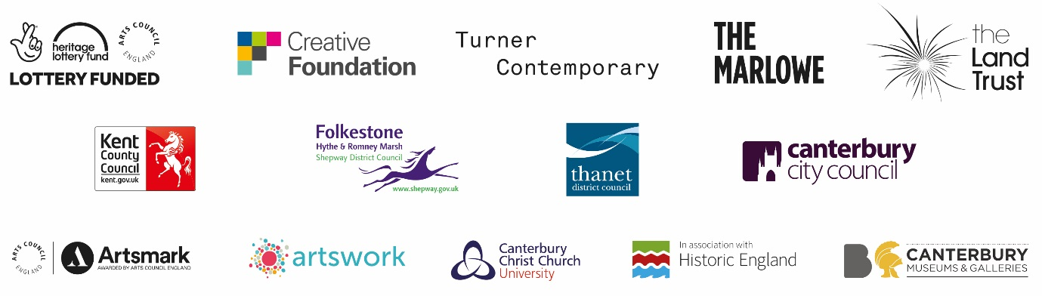

Project Manager for Pioneering Places East Kent: Folkestone
APPLICATION FORM

SECTION 1: APPLICANT DETAILS

Name:
Address:
Mobile number:
Home telephone:
Email address:

Are you legally eligible for employment in the UK?
How did you hear about this opportunity?

What is the earliest you can start working on this programme?

SECTION 2: DECLARATION

Please sign below to indicate that you are providing full and accurate information in your application, including this form, CV and any subsequent interview; and that furthermore you understand that withholding or misrepresenting relevant information may be grounds for the termination of your contract.

Signature: Date:
(FOR OFFICE USE ONLY)
DATE RECEIVED:
DATE OF INITIAL RESPONSE:
SECTION 3:

PLEASE PROVIDE:

- Provide three examples where you were responsible for the delivery of large scale outdoor artworks, along with their budgets and the partners involved.

- Provide three examples of artworks where you were responsible for the community / participatory aspect (please describe the process you managed).

- Please comment on the programme notes above and state what fee you would propose for the delivery of the entirety of the work outlined.

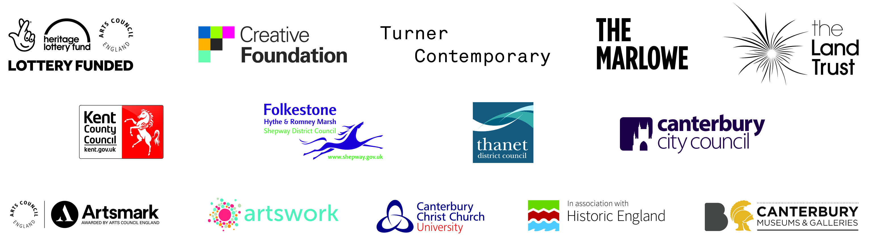

SECTION 4:

REFERENCES
Please provide details of two referees, one of whom is your current or most recent key client, and indicate at which stage you consent for these references to be taken up.

Name: | Relationship to you:
Address: | Contact numbers:
Email address: | Please contact prior to interview  YES/NO

Name: | Relationship to you:
Address: | Contact numbers:
Email address: | Please contact prior to interview  YES/NO

Equal Opportunity Monitoring Questionnaire

This section will only be relevant if you are applying as a sole-trader, rather than a company or institution.

If applicable, it will be separated from your application on receipt. Any information provided is strictly confidential and will not affect your application.

Position: Project Manager, Pioneering Places: East Kent, (Folkestone)

Gender: |  | Male
 |  | Female
 |  | Transgender
 |  | Prefer not to answer
Age: |  | 18 – 25  26 – 35  36 – 45  46 – 55  56 – 65  Over 65
Ethnicity/cultural diversity
Please choose one from A to E, then tick the appropriate box to indicate your background.
A | White
 | British
 | English
 | Scottish
 | Welsh
 | Irish
Any other white background, please write in:
…………………………………………………
B | Mixed
White and Black Caribbean
White and Black African
White and Asian
Any other Mixed background, please write in:
………………………………………………………
C | Asian, Asian British, Asian English, Asian Scottish or Asian Welsh
Indian
Pakistani
 | Bangladesh
 | Any other Asian background, please write in:
 | ……………………………………………………
D | Black, Black British, Black English, Black Scottish or Black Welsh
 | Caribbean
 | African
 | Any other Black background, please write in: ………………………………………………………
E | Chinese, Chinese British, Chinese English, Chinese Scottish, Chinese Welsh
 | Chinese
 | Vietnamese
 | Any other Chinese background, please write in: ……………………………………………………
F | Other Ethnic Group
 | Please write in: …………………………………………………
Disability monitoring
Do you consider yourself disabled?
Yes
No
If you have a disability, is there anything we can do to make our recruitment and selection procedure more accessible to you?
……………………………………………………………………………………………………

